**LEARNING AID FOR AUTISM**

**ABSTRACT:**

Autism also known as ASD (Autism Spectrum Disorder) is a development disorder/disability characterized by challenges with social skills, repetitive behaviour, speech and nonverbal communications. Experts are still uncertain about all the causes of autism. In all likelihood, there are multiple causes – rather than just one. It appears to be that a number of different circumstances — including environmental, biologic, and genetic factors. Globally, autism is estimated to affect 24.8 million people as of 2015. In the 2000s, the number of people affected was estimated at 1–2 per 1,000 people worldwide. There is no exact cure for autism but timely and effective autism treatment can greatly reduce the effect.

The aim of thisAssistive device for Autism is to make the kids suffering from autism learn simple arithmetic operations. This device is intended to help kids for improving their learning abilities in a simplest way. It is a board consisting two sets of numerical input accompanied by a push button respectively. Each set consist of numerical 0-9 and a separate operations button for addition, subtraction, multiplication and division. Whenever a desire operation is selected, an output is shown in the form of an LED for each operation and input buttons selected and will be displayed on an LED screen. In this manner ASD kids can learn some basic arithmetic in a simplest and easy manner.

**HYPOTHESIS:**

* About 1 in 59 children has been identified with autism spectrum disorder (ASD) according to estimates from CDC’s Autism and Developmental Disabilities Monitoring (ADDM) Network.
* ASD is reported to occur in all racial, ethnic, and socioeconomic groups.
* ASD is about 4 times more common among boys than among girls.
* Studies in Asia, Europe, and North America have identified individuals with ASD with an average prevalence of between 1% and 2%.
* About 1 in 6 children in the United States had a developmental disability in 2006-2008, ranging from mild disabilities language impairments to serious developmental disabilities, such as intellectual disabilities, cerebral palsy, and autism.

Through this system, children who are suffering from Autism will be able to perform Arithmetic operations.

**METHOD:**

In this devices, switches and LED’s are used for the input (0-9) and operator selector in which the LED will glow according to the selected number by pressing the switches. For the first input, ten switches and ten LED’s are used, ten switches and ten LEDs are again used for second input and also four switches are used for the operators (+, -, /, *). For the output, green and red LED are used which will be attractive for the children. By selecting any number from the first input, the respective LED will glow and again selecting for the desired operator by pressing the switches, we will again select the second input by pressing the switches in which the respective LED will glow. After finish selecting, we will get the required output automatically by glowing LED. All these switches, LED and any other connection implementation are done in the board. The board is paint colourful as possible whereas the LED used is also green and red to make more attractive and eye catchy for the children, this device is design in such a way that the children should get more interest even by the looks as compare to any other devices.

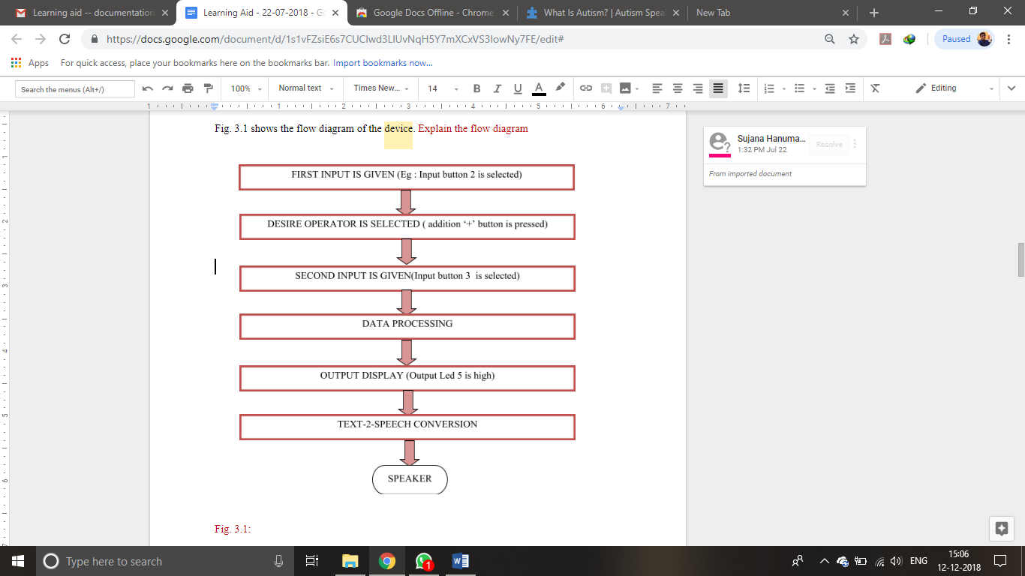

**EXPERIMENT:**

The components used in this experiment are:

* Processor - ATMEGA
* LCD screen -20x4
* Turn on pushbuttons
* LED’s (Red, Green, Yellow)
* Text to speech module

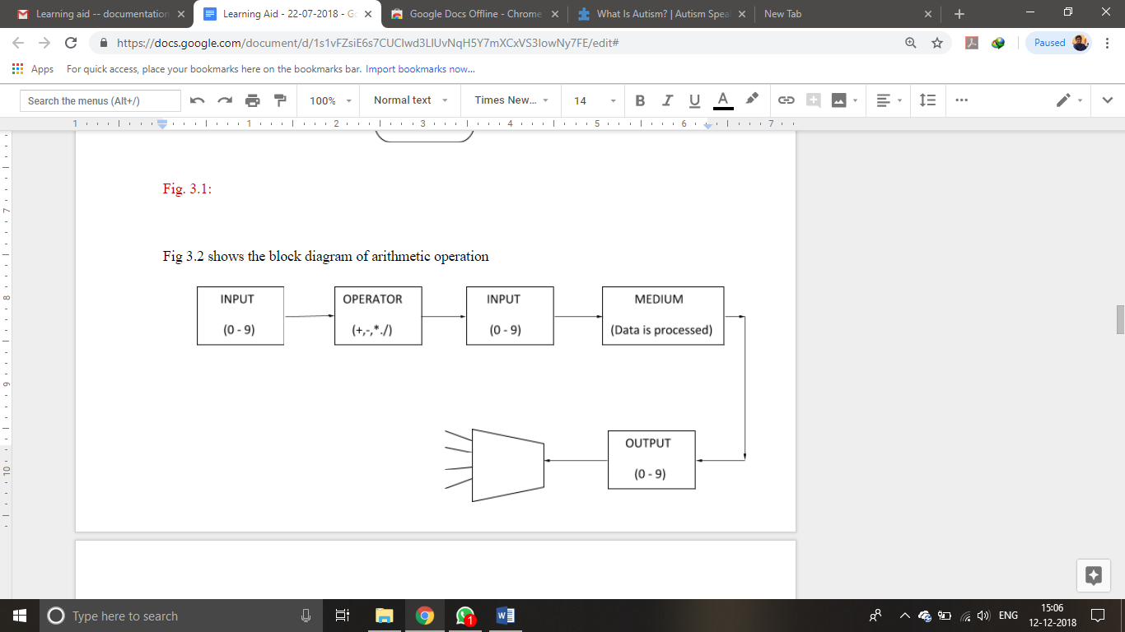

First, powerup the device using 9V adapter. Then, the user selects the first digit and respective LED will be glows, and that digit will be displayed on LCD screen and that digit will be pronounced by text to speech module. Then, the user selects the operation such as +, -, and / to be performed, and then he selects another digit.

The above process will be followed in case of selecting the operation and next digit.

Here, the user has formed an expression, for example 2+3, and then this

expression will be passed to the processor and the respective operation will be

performed. The result will be displayed on the LCD screen as 2+3=5. Using Text-

to-speech module, the whole equation will be voiced over.

In this way, this tool helps the users suffering from Autism.

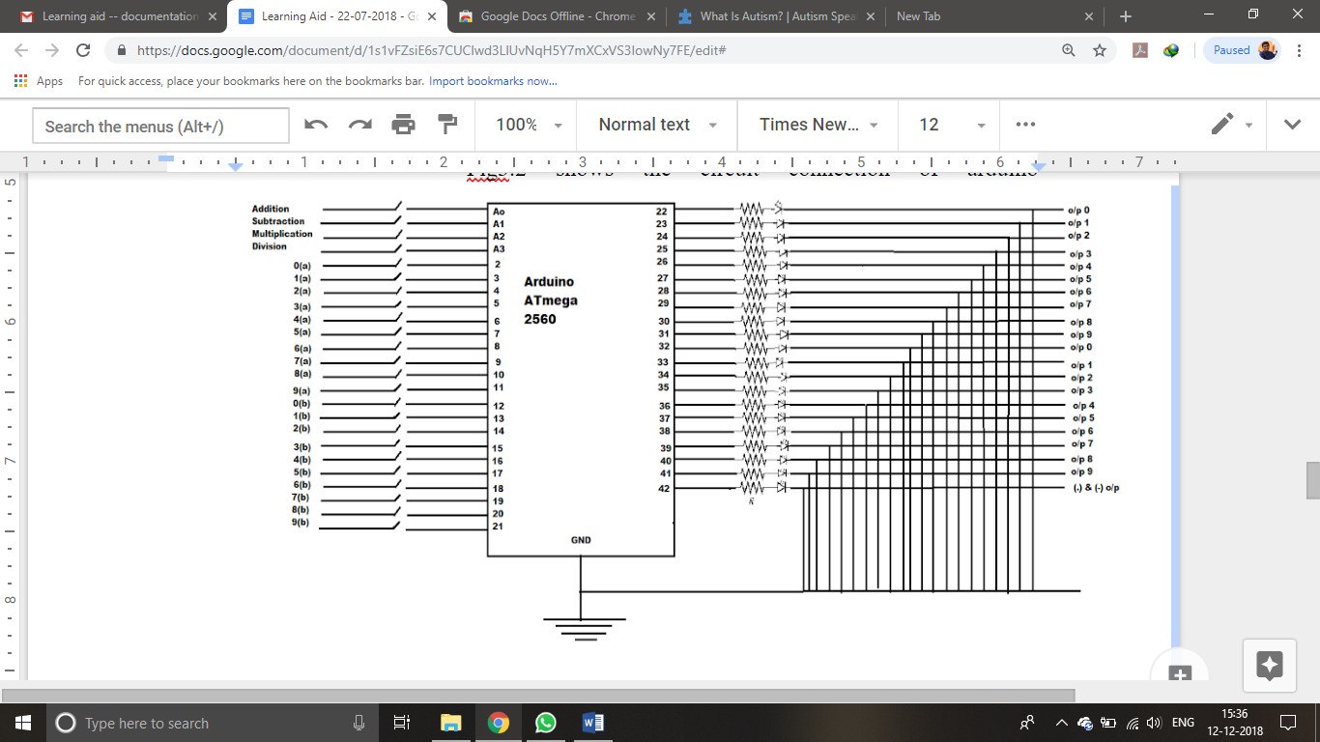

**Summary:**

Using our learning aid the children who are suffering from autism will be able to improve their IQ levels with the help of colourful lights in the device the child will be attracted towards the numbers and will be able to recognize the numbers and will be able to perform operations. The Text to speech module present in the device will help to gain the attention of child. In this way, the Autism Learning Aid will be helpful to children who are suffering with autism.

**Cost:** Rs 3500/-